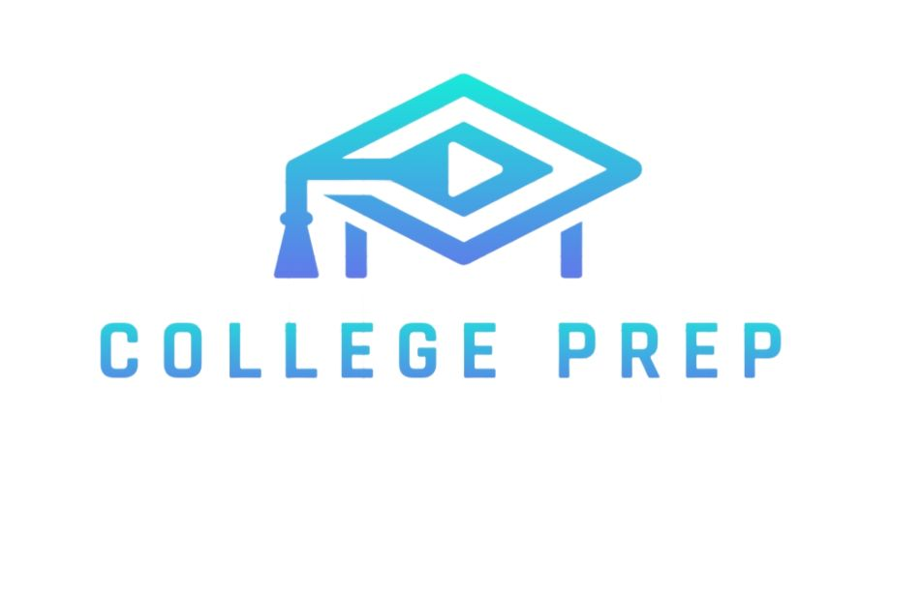

COLLEGE PREP

– Summer Plan 2026

This summer can literally change your next 2–3 years if you use it properly
This plan is divided separately for DSA and Development because every student has different goals and interests.
Some may want to focus completely on DSA for placements, while others may want to explore Development, AI/ML, or Full Stack.
So based on your current level, interests, and future goals, choose the path and plan accordingly

SUMMER 2026

↓

Choose Your Goal

↙ ↓ ↘

DSA DEV AI/ML

↓ ↓ ↓

Learn Basics Build UI Python + Math

↓ ↓ ↓

Solve Problems APIs ML Foundations

↓ ↓ ↓

Contests Full Stack AI Projects

↘ ↓ ↙

Build Portfolio

↓

Internships

↓

Placements

DSA PLAN
Try to give around 6–7 hours daily for DSA. Make your schedule accordingly.

Plan:
- Learn one topic properly
- Solve Easy → Medium problems
- Revise old topics weekly
- Practice consistently every day

Resources:
TUF : https://takeuforward.org/dsa/strivers-a2z-sheet-learn-dsa-a-to-z Learnyard : https://learnyard.com/practice/dsa
Love-babbar : https://www.geeksforgeeks.org/dsa/dsa-sheet-by-love-babbar/

Practise platforms:

Leetcode

HackerRank

CodeForces

Greeks For Greeks (GFG)

Mistakes To Avoid:

❌ Watching DSA tutorials without solving problems

❌ Jumping directly to hard problems too early

❌ Learning too many topics together and getting overwhelmed

❌ Not revising previously learned concepts regularly

❌ Being inconsistent and solving problems only occasionally

DEVELOPMENT PLAN

Full Stack Development
Roadmap: roadmap.pdf.pdf

Resources:
Sangammukherjee (Follow this channel) : https://www.youtube.com/@sangammukherjee

ML
Roadmap : Curriculum for Machine Learning Course.docx

Resources:
Siddhardhan :
https://www.youtube.com/watch?v=bY YW-xknU&list=PLfFghEzKVmjsNtIRwErklMAN8nJm ebB0I

AI
Roadmap : https://ai-engineer.harshhh.me/

Resources:
SheryiansAI : https://www.youtube.com/@SheryiansAI/featured

Best Free Platforms
💻 Development
• Frontend Mentor
• GitHub
• Vercel
🤖 AI/ML
• Kaggle
• HuggingFace
• Google Colab
DSA + DEV BOTH
In the starting phase, managing both together is honestly very difficult But if you already have some basics, you can try balancing both.

Example Schedule(Not compulsory) :
- 9 AM – 3 PM → DSA
- 7 PM – 11 PM → Development Consistency matters more than motivation

CORE SUBJECTS
Don’t ignore core subjects Important ones:

- DBMS :
Launching DBMS Course 🔥 | Placements | Semester Exams | 2024

- OOPS :
OOPs Tutorial in One Shot | Object Oriented Programming | in …

- CN :
Computer Networking Full Course - OSI Model Deep Dive with R…

- OS :
Introduction to Operating Systems Placements Course 2022

START NOW.
YOUR FUTURE SELF WILL THANK YOU.

After Summer:

• Start building resume

• Apply for internships

• Participate in hackathons

• Build LinkedIn properly

• Continue DSA consistency

Follow Collegeprep for more Updates :

https://whatsapp.com/channel/0029Vb6YAwDEVccElmZHow37

💙 Support College Prep
Building this takes real time & effort 📚
If it helped you, support here ☕
👉https://support-collegeprep.netlify.app/
Every small support matters
Website : www.collegeprep.page
Follow the College Prep channel on WhatsApp: https://whatsapp.com/channel/0029Vb6YAwDEVccElmZHow37
Follow this link to join my WhatsApp group:
https://chat.whatsapp.com/DeC2kGbiK1tDnegSZkCLnT

